Prac 5 23/06/2023

Q.Compare two files City1 and City2.



Q. Compare two files a1 and a2

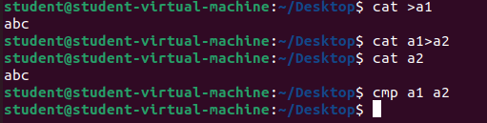

Q. Display the common lines between City1 and City2.

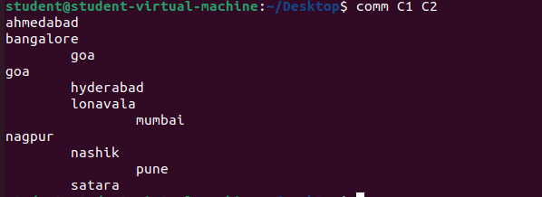

**Q. Display common lines between two files a1 and a2**



**Q. Display unique lines of file City1.**

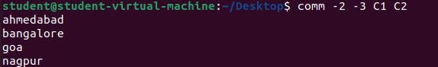

**Q.Display unique lines of file City2.**

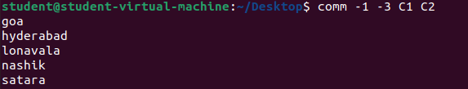

**Q.Display common lines between City1 and City2**

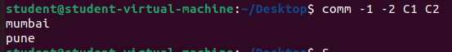

**Q. Display unique lines of file C1 and C2.**

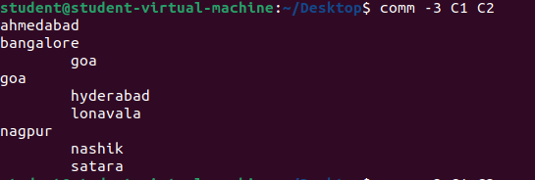

**Q.Display unique lines of file C1 and common lines between C1 C2.**

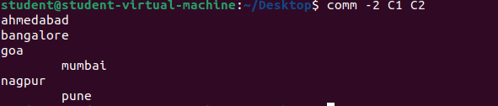

**Q. List the difference of all characters of file C1 and C2.**

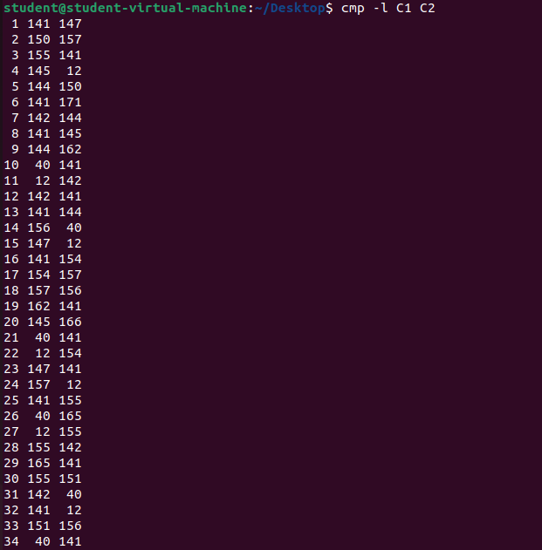

**Q.Find the difference of lines in C1 and C2.**

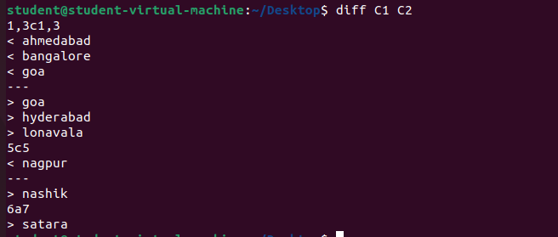

**Q. Create the file with the name numbers having some set of numbers.**

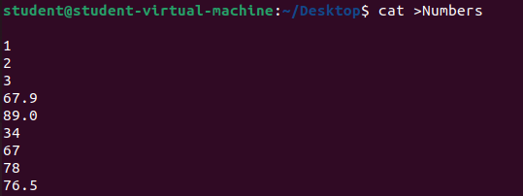

**Q.Create the file with the name of student1 having fields rollno,name ,marks,grade,remarks.**

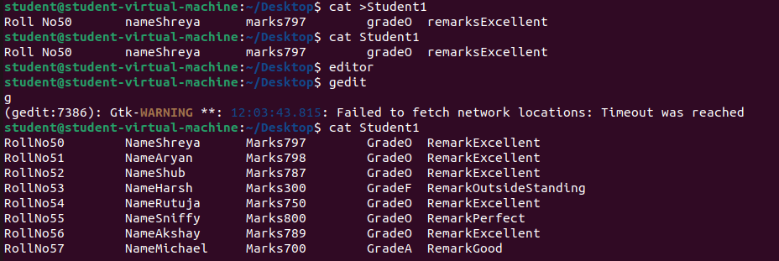

**Q.All the fields should be separated by a delimiter tab.Insert atleast 7 records into this file.**

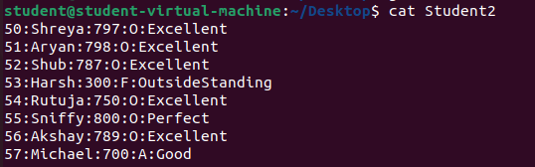

**Q. Sort the numbers in ascending order of file numbers.**

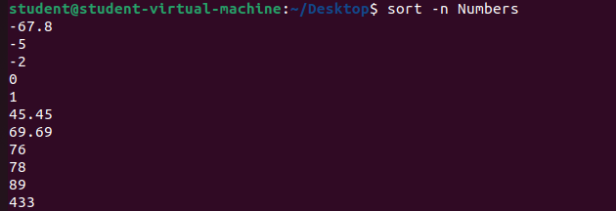

**Q. Sort the numbers in desceding order of file numbers.**

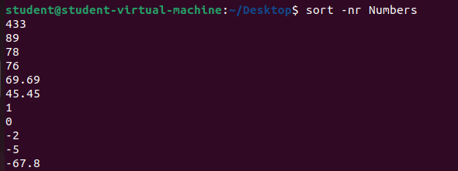

**Q. Sort the content of file c1 in reverse order.**



**Q.Sort the content of file c2 in reverse order.**

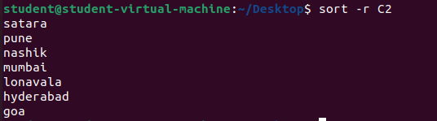

**Q. Store the sorted reversed content of file c1 into new file rc1.**

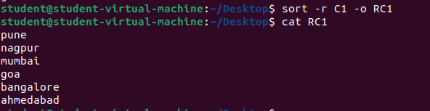

**Q. Store the sorted reversed content of file c2 into new file rc2.**

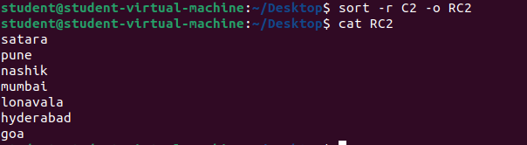

**Q. Sort Student’s name of file Student1.**

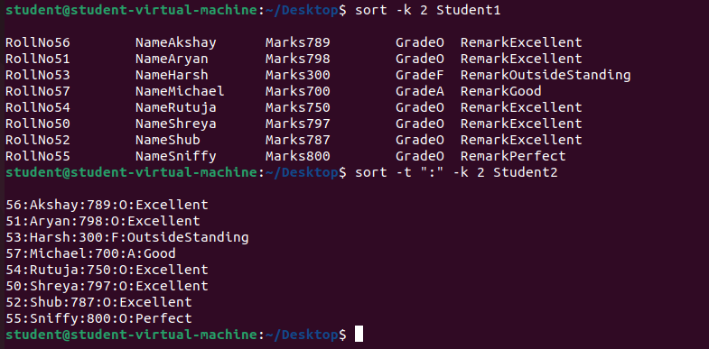

**Q. Sort Student’s Marks of file Student1.**

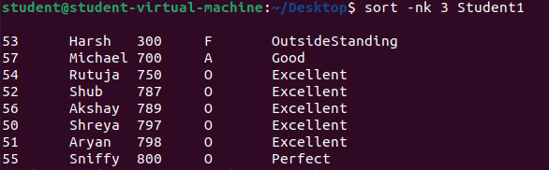

**Q. Sort Student’s Marks of file Student2.**

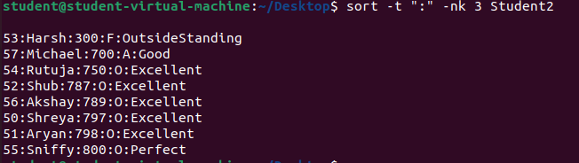

**Q. Sort the names in descending order of Student1.**

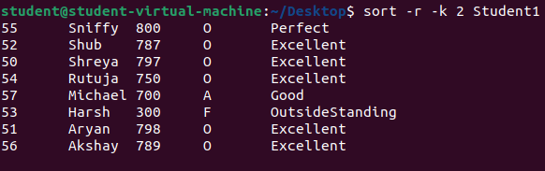

**Q. Sort the names in descending order of Student2.**

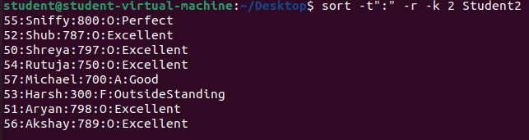

**Q. Sort the marks in descending order of Student1.**

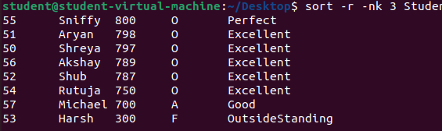

**Q. Sort the marks in descending order of Student2.**

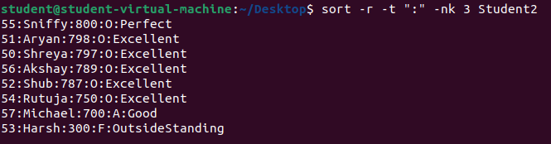

**Q. Check whether the following files are sorted:City1,City2,C1,C2,a1,a2.**

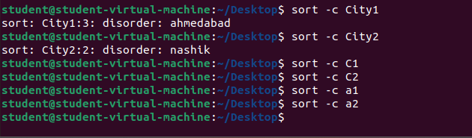

**Q. Display student roll no and remarks of all students from file Student1.**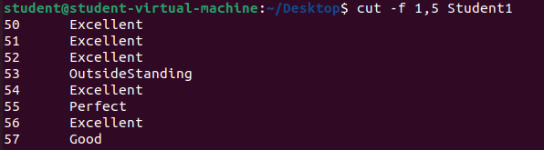

**Q. Display student roll no and remarks of all students from file Student2.**

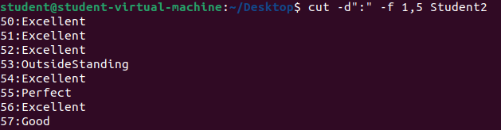

**Q. Display student’s marks grade and remarks of all students from Student1.**

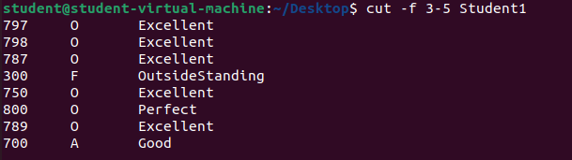

**Q. Display student’s marks grade and remarks of all students from Student2.**

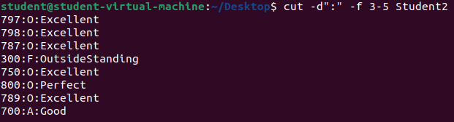

**Q. Store students roll no from file student1 into new file s1 and display its content.**

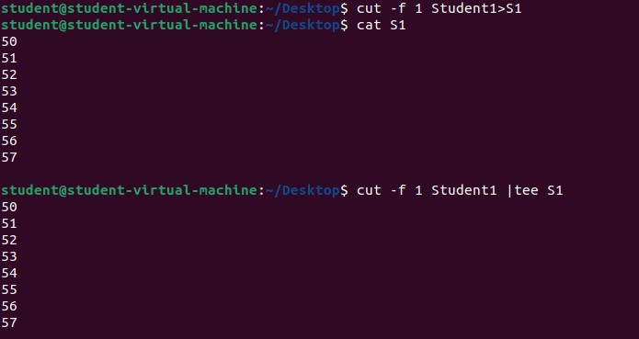

**Q.Store and display students grade and remarks from student1 into new file s2.**

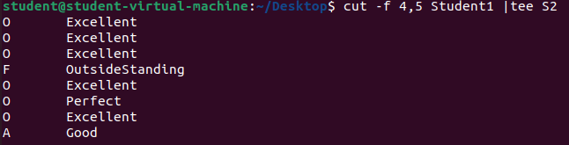

**Q. Paste the contents of files s1 and s2 vertically.**

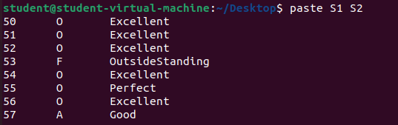

**Q. Paste the contents of files s1 and s2 vertically then store and display the output into new file s3.**

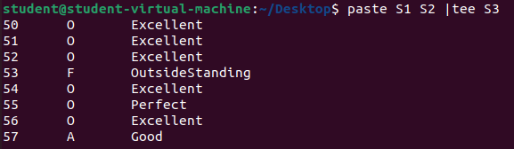

**Q. Store and display its content students roll no from file student2 into new file s4.**

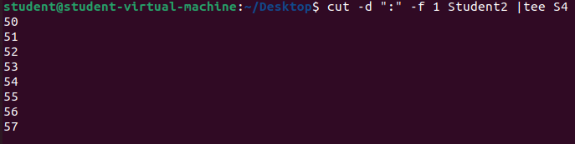

**Q.Store and display students grade and remarks from student2 into new file s5.**

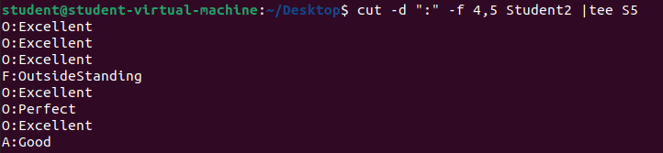

**Q.Paste S4 and S5.**

